
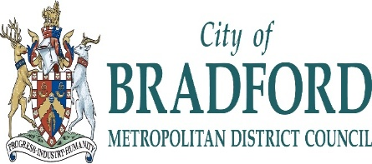

Bradford Council – Skills for Work Sustainability Policy
1. Purpose
This policy outlines Bradford Council’s commitment to sustainability within Skills for Work provision. It aims to embed environmentally responsible practices, promote social value, and ensure economic resilience in all aspects of service delivery, partnerships, and operations.
2. Scope
This policy applies to all Skills for Work staff, learners, contractors, and stakeholders involved in programme delivery across the Bradford District.
3. Policy Statement
Skills for Work is committed to:
- Reducing its environmental footprint.
- Promoting sustainable employment and skills development.
- Supporting Bradford Council’s wider sustainability and climate action goals.
4. Objectives
We will:
- Minimise Waste and Resource Use
Reduce paper usage, promote digital learning, and recycle materials wherever possible.
- Promote Sustainable Travel
Encourage staff and learners to use public transport, car share, cycle, or walk where feasible.
- Support Green Skills and Jobs
Integrate sustainability themes into curriculum and training, preparing learners for emerging green sectors.
- Procure Responsibly
Work with suppliers who demonstrate sustainable practices and ethical standards.
- Reduce Energy Consumption
Use energy-efficient equipment and promote energy-saving behaviours in all learning environments.
- Raise Awareness
Provide training and resources to staff and learners on sustainability and climate change.
- Monitor and Improve
Regularly review sustainability performance and seek continuous improvement.
5. Responsibilities
- Skills for Work Principal: Oversees implementation and ensures alignment with council-wide sustainability strategies.
- All Staff: Expected to follow sustainable practices and promote them to learners.
- Learners: Encouraged to engage with sustainability initiatives and apply them in their learning and future employment.
6. Review and Reporting
This policy will be reviewed annually and updated in line with Bradford Council’s sustainability goals and national guidance. Progress will be reported to the Skills for Work leadership team and shared with stakeholders.

Suzan Mc Gladdery
Principal Skills for Work
Review date 10/11/25
Review Date 10/11/26
Sustainability | Bradford Council

